**Python Assignment 1**

**Name: Sharmela C**

**Roll no: 1717142**

**CSE-IV year**

**Question 1:** Get input from user and find whether it is odd/even

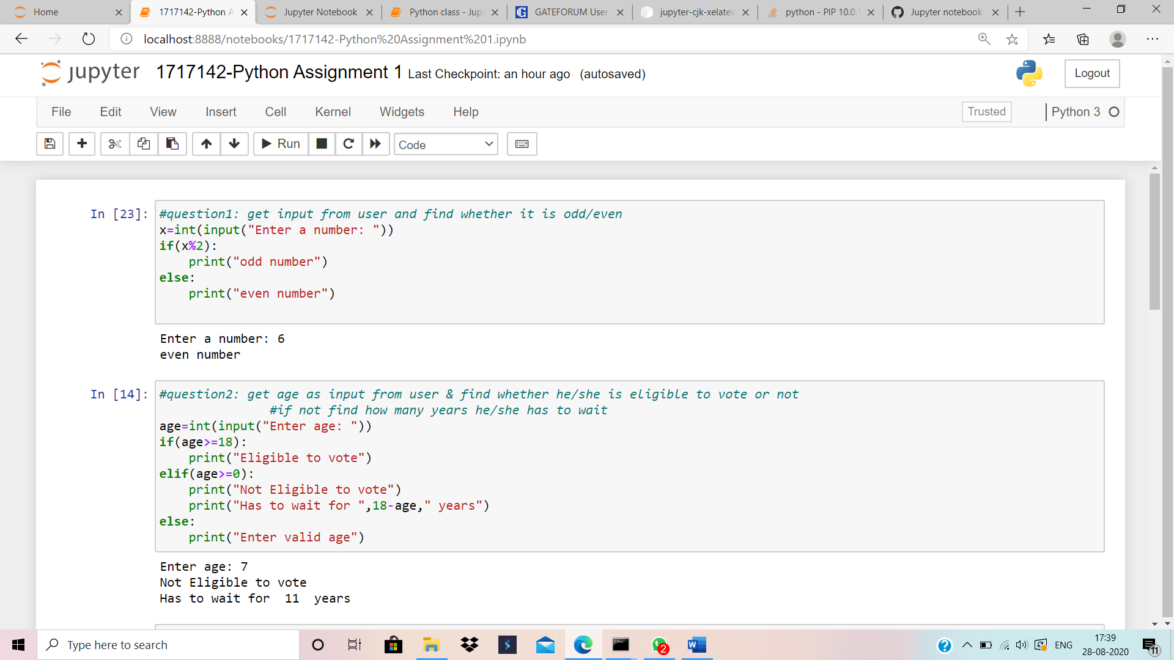

**Question 2:** Get age as input from user and find whether he/she is eligible to vote or not, if not find how many years he/she has to wait.

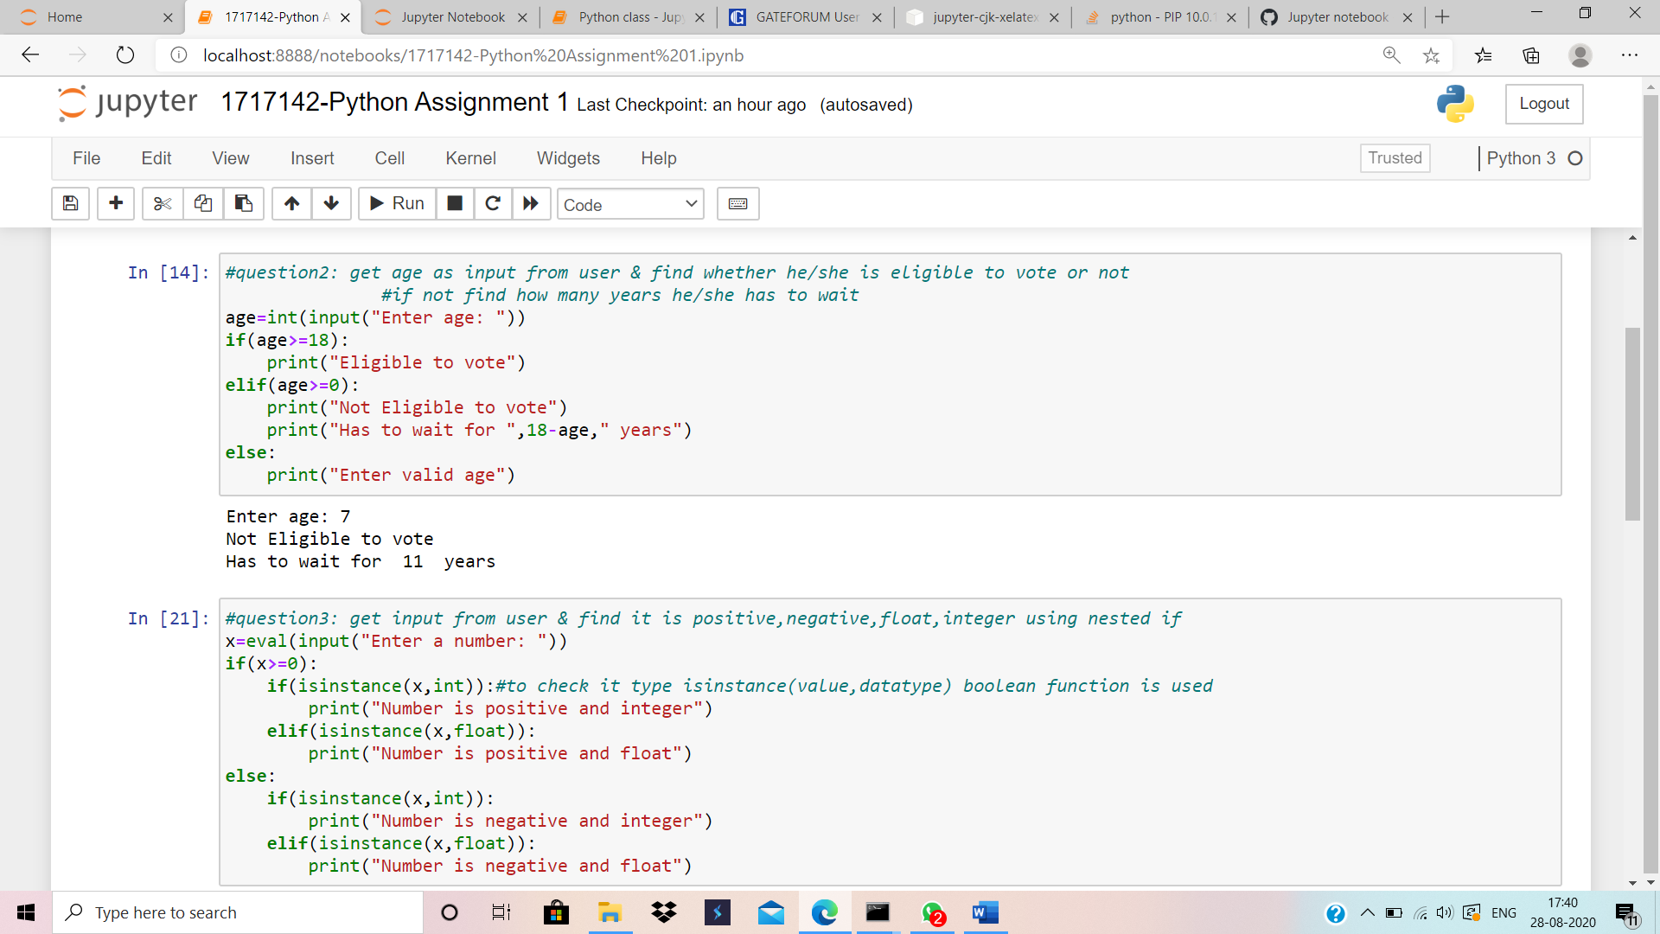

**Question 3:** Get input from user and find it is positive,negative,integer or float using nested if

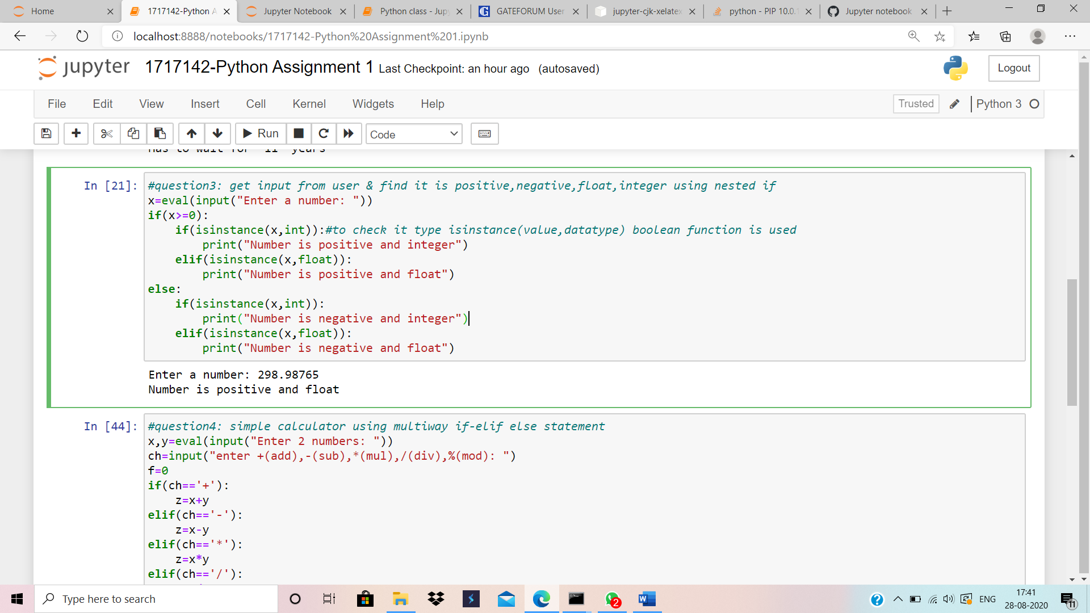

**Question 4:** Simple calculator using multiway if-elif statement

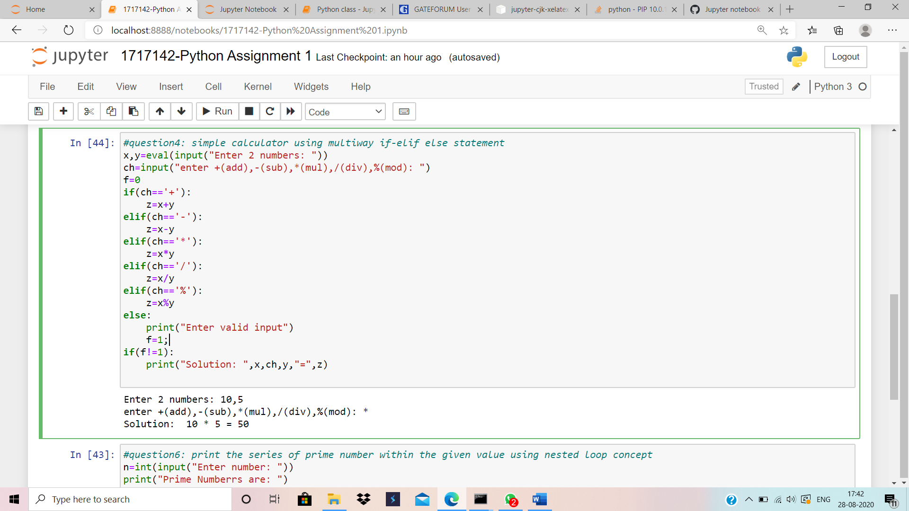

**Question 6:** Print the series of prime number within the given value using nested loop concept

